Name: _____________________ Date: ___________ Section: __________

Charles’ Law

Procedure Summary

Type a summary of the experimental procedure below, in your own words.

The objective of this experiment is to investigate the effect of increasing temperatures on the volume of the gas. We investigate how closely an actual sample of gas adheres to the Charles’ law via measuring the volumes VI, and V2 of the same sample but at two kelvin temperatures T1 and T2 respectively.
The first step is to use a clean paper towel to dry a 125 mL Erlenmeyer flask and tightly stopper the flask with a rubber stopper which has a center hole that has been bored. Using a marking pen, mark the position of the bottom of Erlenmeyer flask. After that use a beaker than is large enough to hold the 125 Erlenmeyer flask with ease. Place the beaker on a square of wire gauze on top of a tripod stand. The next step is to attach a clamp on the neck of the Erlenmeyer flask and carefully put it inside the beaker and after that screw the clamp to a ring stand for support.
Put water into the beaker while ensuring that the Erlenmeyer flask is immersed into the water almost to the brim. Then place a Bunsen burner below the assembly and light the burner while slowly heating the water to a calm boil for close to 7 minutes.
The fill a small clear plastic tube with 50:50 mixture of ice and tap water. The temperature of the ice water needs to be constant and below 6 oC and when the temperature increases above 6 oC put more ice water.
After the water put in beaker has boiled for 7 minutes, extinguish the Bunsen burner and cover the hole in the stopper tightly with finger pressure and unscrew the clamp around its Erlenmeyer flask’s neck from the other assembly. Ensure that no bubble escapes to ensure accuracy of the results. Keep the flask under water for 6 minutes while ensuring that most of flask surface is submerged in water. After the duration of 5 minutes remove the flask from the cold bath. Raise as well as lower the flask to ensure that water level inside the flask matches the water level of the ice water mixture. Thereafter, remove the flask from cold bath at the same time remove the clamp and the stopper. Lastly, transfer the cold water obtained onto a graduated cylinder that the surface which had earlier been dried with clean paper towel and measure the volume as Vx mL. the next step is to put fresh water into an empty Erlenmeyer flask to the level you made earlier while identifying the position of the bottom of the stopper and transfer the contents to a graduated cylinder and measure the volume and label it as Vy. It is necessary to repeat the process at least two times for accurate results.

Name: _____________________ Date: ___________ Section: __________

CHARLES’ LAW

Pre-Lab Questions

- The following data was plotted on the graph below. Based on this graph, predict a value for Absolute Zero and type it in the space provided.

Temperature of Air (ºC)  (x-axis) | Volume of Air (mL)  (y-axis)
100 | 140
20 | 110
4 | 105

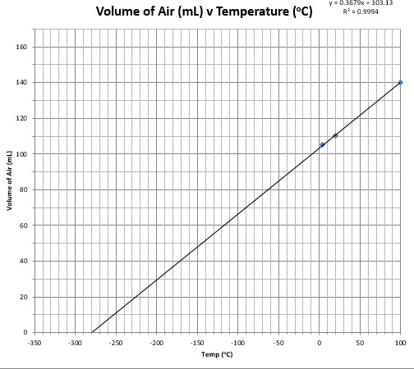

Based upon this graph, Absolute Zero = ___-280_____ºC

- Based upon the graph in question 1, how does a decrease in temperature affect the volume of the gas (the pressure and amount of gas is held constant)?

Answer: A decrease in temperature has a corresponding decrease on the volume of the gas. At -280 ºC the volume is 0 ml while at 100 ºC the volume is at 140 ML. This is because of the decrease in the kinetic energy which results in an decrease in volume as illustrated in the graph.

- Charles’ Law allows the prediction of gas volumes at different temperatures. What would the volume of a gas be at 38.3ºC if it started at a volume of 45.7mL and a temperature of -58.5 ºC?
Remember that temperatures must be in Kelvin when performing Gas Law calculations.

Answer: The volume at 38.3 ºC is at 66.26ML
Volume at -58.5 ºC is 45.7ml

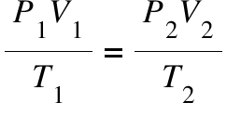
Where
T1=273+-58.3=214.7k
T2=273+38.3=311.3k
V1=45.7ml
V2=?
=(45.7/214.7)X311.3
=66.26 Ml

- Using the raw data from question 3 as an example, explain why temperature must always be converted to Kelvin when using gas law equations.

Answer: The Kelvin scale is adopted in the gas law problems since the pressure and the volume of a gas is depended on the motion of the particles (kinetic energy). Since the Kelvin scale is proportional to the KE of the particles which implies that 0 K (absolute Zero) is a 0 kinetic energy.

- Charles’ Law applies when gases are behaving as Ideal Gases. Can you assume that the gas will behave ideally during this experiment? Explain.

Answer: Yes, this gas in this experiment will behaves like an idea gas. The results illustrate that a decrease in volume when temperature is decreased under the conditions that pressure is constant. The effect of the intermolecular forces is regarded more prominent when exposed to low temperatures since the molecules have a lesser kinetic energy to overcome the intermolecular attractions.

CHARLES’ LAW

Experimental Data

Experimental Procedure - Part 1 (Tap Water)
15) A student measured the temperature of the tap water bath, and found it to be 25.0 °C.

18) The student poured the tap water from the Erlenmeyer flask into a graduated cylinder and found the volume of the water to be 25 mL.

Experimental Procedure – Part 2 (Ice-Water)
15) A student measured the temperature of the ice-water bath, and found it to be 13.0 °C.

18) The student poured the ice-water from the Erlenmeyer flask into a graduated cylinder and found the volume of the water to be 33 mL.

Experimental Procedure – Part 3 (Boiling Water)
23 g) The student poured the combined contents of the Erlenmeyer flask and small glass tube into a graduated cylinder and found the total volume of the water to be 141 mL.

26) The student read the Barometric Pressure of the room, and found it to be 738.6 torr. Consulting the CRC Handbook, the student determined that the temperature of boiling water at that pressure is 99.203 °C.

Instructions
Use the data provided to complete the data table on the next page.
In the Charles’ Law folder of the Lab Community, open the Excel file labeled “Charles Law Graphing”. Plot a graph of the Volume of Air versus Temperature by inputting the data from your data page into the table on the Excel spreadsheet (do not enter units). You must enter three sets of data (t₁ vs. v₁, t₂ vs. v₂ and t₃ vs.v₃). Save your graph to submit with your lab report.
NOTE: Be sure to use the Volume of Air and NOT the Volume of Water when plotting the graph.
From the extrapolated line on the graph, obtain a value for Absolute Zero in °C (the point where your line crosses the x-axis). Record your experimental value for Absolute Zero on the data page.
Name: _____________________ Date: ___________ Section: __________

CHARLES’ LAW

Experimental Data and Results

Refer to the Experimental Data provided, and enter it into the table.

Data Table
 | Temperature (°C) | Volume of Water (mL) | Volume of Air (mL)  (Total Volume of flask – Volume of water)
Part 1  (t₁, v₁) | 25 | 25 | 116
Part 2  (t₂, v₂) | 13 | 33 | 108
Part 3  (t₃, v₃) | Temperature of Boiling water:  99.203 |  | Total Volume of Flask:  141

Barometric Pressure: ____738.6_________ torr

Prediction of Absolute Zero as determined from the graph:

Absolute Zero: ___103_________ ºC

